**2nd Quarter Cumulative Assessment**

1. The Taylor series for a function $f$ about $x=0$ is given by $∑_{n=1}^{∞} \frac{(-1)^{n+1}}{(2n+1)!}x^{2n}$ and converges to $f$ for all real numbers $x$. If the fourth-degree Taylor polynomial for $f$ about $x=0$ is used to approximate $f\left(\frac{1}{2}\right)$, which of the following given the alternating series error bound?

(A) $\frac{1}{2^{4}⋅5!}$

(B) $\frac{1}{2^{5}⋅6!}$

(C) $\frac{1}{2^{6}⋅7!}$

(D) $\frac{1}{2^{10}⋅11!}$

$∫\frac{x}{2}e^{-3x/4}dx=$

(A) $-\frac{3x}{4}e^{-3x/4}+\frac{3}{4}e^{-3x/4}+C$

(B) $-\frac{2x}{3}e^{-3x/4}-\frac{8}{9}e^{-3x/4}+C$

(C) $-\frac{x}{2}e^{-3x/4}+\frac{3}{8}e^{-3x/4}+C$

(D) $\frac{x}{2}e^{-3x/4}-\frac{1}{2}e^{-3x/4}+C$

1. Which of the following series are *conditionally* convergent?

i. $∑_{n=1}^{∞} \frac{(-1)^{n}}{n}$

ii. $∑_{n=1}^{∞} \frac{(-1)^{n}}{n^{3}}$

iii. $∑_{n=1}^{∞} \frac{(-1)^{n}}{\sqrt{n}}$

(A) I only

(B) I and II only

(C) I and III only

(D) II and III only

1. Which of the following series converge?

I. $∑_{n=1}^{∞} \frac{|sin⁡n|}{n^{2}}$

II. $∑_{n=1}^{∞} e^{-n}$

III. $∑_{n=1}^{∞} \frac{n+2}{n^{2}+n}$

(A) I only

(B) II only

(C) III only

(D) I and II only

(E) I and III only

1. What are all values of $p$ for which the series $∑_{n=1}^{∞} \frac{1}{n^{2p}+n}$ diverges?

(A) $p≤1/2$

(B) $p<1/2$ only

(C) $p≥1/2$

(D) $p>1/2$ only

(E) The series diverges for all $p$.

1. Which of the following definite integrals has the same value as $∫_{0}^{4} xe^{x^{2}}dx$?

(A) $\frac{1}{2}∫_{0}^{4} e^{u}du$

(B) $\frac{1}{2}∫_{0}^{16} e^{u}du$

(C) $2∫_{0}^{2} e^{u}du$

(D) $2∫_{0}^{4} e^{u}du$

(E) $2∫_{0}^{16} e^{u}du$

1. $∫_{1}^{∞} \frac{x^{2}}{{\left(x^{3}+2\right)}^{2}}dx$ is

(A) $-\frac{1}{9}$

(B) $\frac{1}{9}$

(C) $\frac{1}{3}$

(D) 1

(E) divergent

1. The third-degree Taylor polynomial for a function $f$ about $x=4$ is $2+\frac{(x-4)}{4}-\frac{(x-4)^{2}}{64}+\frac{{(x-4)}^{3}}{512}$. What is the value of $f^{'''}(4)$?

(A) $-\frac{1}{64}$

(B) $-\frac{1}{32}$

(C) $\frac{1}{512}$

(D) $\frac{3}{256}$

(E) $\frac{81}{256}$

$∫\frac{3x+1}{x^{2}-4x+3}dx=$

(A) $-2ln⁡|x-3|+5ln⁡|x-1|+C$

(B) $\frac{1}{5}ln⁡|x-3|-\frac{1}{2}ln⁡|x-1|+C$

(C) $\frac{1}{2}ln⁡|x-3|-\frac{1}{2}ln⁡|x-1|+C$

(D) $5ln⁡|x-3|-2ln⁡|x-1|+C$

$∫cos⁡(3x)dx=$

(A) $-3sin⁡(3x)+c$

(B) $-\frac{1}{3}sin⁡(3x)+c$

(C) $\frac{1}{3}sin⁡(3x)+c$

(D) $sin⁡(3x)+c$

(E) $3sin⁡(3x)+c$

1. Which of the following is the interval of convergence for the series $∑_{n=0}^{∞} \frac{(x+2)^{n}}{2^{n}}$?

(A) $-4<x<0$

(B) $-4≤x<0$

(C) $-2<x<0$

(D) $-2≤x<2$

1. Which of the following is the Maclaurin series for $e^{3x}$?

(A) $1+x+\frac{x^{2}}{2}+\frac{x^{3}}{3!}+\frac{x^{4}}{4!}+⋯$

(B) $3+9x+\frac{27x^{2}}{2}+\frac{81x^{3}}{3!}+\frac{243x^{4}}{4!}+⋯$

(C) $1-3x+\frac{9x^{2}}{2}-\frac{27x^{3}}{3!}+\frac{81x^{4}}{4!}-⋯$

(D) $1+3x+\frac{3x^{2}}{2}+\frac{3x^{3}}{3!}+\frac{3x^{4}}{4!}+⋯$

(E) $1+3x+\frac{9x^{2}}{2}+\frac{27x^{3}}{3!}+\frac{81x^{4}}{4!}+⋯$

1. A curve is defined by the parametric equations $x(t)=e^{-3t}$ and $y(t)=e^{3t}$. What is $\frac{d^{2}y}{dx^{2}}$ in terms of $t$?

(A) $-6e^{6t}$

(B) $6e^{6t}$

(C) $\frac{1}{3}e^{9t}$

(D) $2e^{9t}$

14.

|  |  |  |  |  |
| --- | --- | --- | --- | --- |
| $$x$$ | $$f(x)$$ | $$f^{'}(x)$$ | $$f^{''}(x)$$ | $$f^{'''}(x)$$ |
| 0 | 2 | -1 | 3 | 5 |
| 2 | 3 | -2 | 7 | -1 |

The table above gives values of a function $f$ and its derivatives at selected values of $x$. Which of the following is the third-degree Taylor polynomial for $f$ about $x=2$?

(A) $2-x+\frac{3}{2}x^{2}+\frac{5}{6}x^{3}$

(B) $2-x+\frac{3}{2}x^{2}+\frac{5}{3}x^{3}$

(C) $3-2(x-2)+\frac{7}{2}(x-2)^{2}-\frac{1}{6}(x-2)^{3}$

(D) $3-2(x-2)+\frac{7}{2}(x-2)^{2}-\frac{1}{3}(x-2)^{3}$

1. What is the sum of the series $\frac{π}{e}-\frac{π}{e^{2}}+\frac{π}{e^{3}}-\frac{π}{e^{4}}+⋯+(-1)^{n+1}\frac{π}{e^{n}}+⋯$? (Remember, $e≈2.718$)

(A) $\frac{π}{e+π}$

(B) $\frac{π}{e+1}$

(C) $\frac{π}{e-1}$

(D) The series diverges.

1. A curve $C$ is defined by the parametric equations $x(t)=3+t^{2}$ and $y(t)=t^{3}+5t$. Which of the following is an equation of the line tangent to the graph of $C$ at the point where $t=1$?

(A) $y=(1/4)x+5$

(B) $y=4x-10$

(C) $y=4x+6$

(D) $y=8x-26$

(E) $y=8x+6$

1. The vector-valued function $h$ is defined by $h(t)=\left\langle te^{t},t^{2}e^{t}\right\rangle$. Which of the following is $h^{'}(1)$?

(A) $\frac{3}{2}$

(B) 2

(C) $⟨e,2e⟩$

(D) $⟨2e,3e⟩$

18.

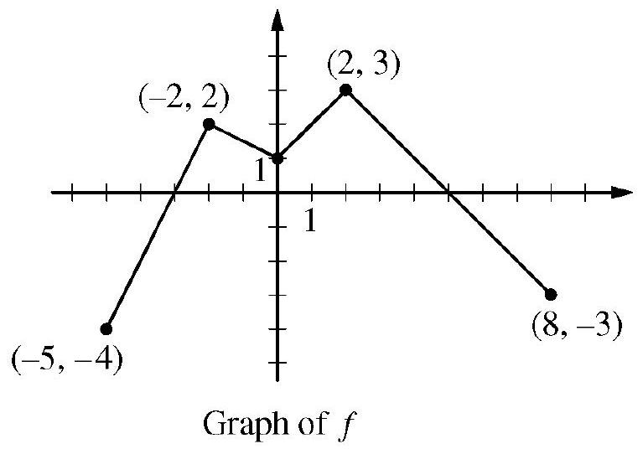

The continuous function $f$ is defined on the interval $-5≤x≤8$. The graph of $f$, which consists of four line segments, is shown in the figure above. Let $g$ be the function given by $g(x)=2x+∫_{-2}^{x} f(t)dt$.

(a) Find $g(0)$ and $g(-5)$.

(b) Find $g^{'}(x)$ in terms of $f(x)$. For each of $g^{''}(4)$ and $g^{''}(-2)$, find the value or state that it does not exist.

(c) On what intervals, if any, is the graph of $g$ concave down? Give a reason for your answer.

(d) The function $h$ is given by $h(x)=g\left(x^{3}+1\right)$. Find $h^{'}(1)$. Show the work that leads to your answer.